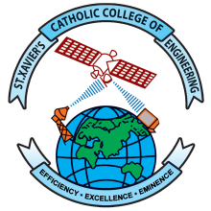 | St. Xavier’s Catholic College of Engineering  An Autonomous Institution, Affiliated to Anna University, Chennai  Chunkankadai, Nagercoil – 629003  End-Semester Practical Examination

Nov./Dec. YYYY / April/May YYYY Examinations
Department of …
Time Table
Subject Code and Title :
Degree and Branch :
Semester :
Venue :
Date | Time | Register Number | Total Students
DD-MM-YYYY | 9:00 a.m. to 12:00 p.m.
DD-MM-YYYY | 12:30 p.m. to 3:30 p.m.
DD-MM-YYYY | 9:00 a.m. to 12:00 p.m.
DD-MM-YYYY | 12:30 p.m. to 3:30 p.m.
Discrepancy, if any, can be brought to the knowledge of the HOD.

HOD Principal

